Marketplace Ideation

https://www.sharetribe.com/academy/how-to-come-up-with-a-great-marketplace-idea/

Platform name:

Short description:

Model:

Taxonomy

Dimension | Value
User Type^{m} | Person |  |  |  | Organization
Listing Kind^{m} | Good Transfer |  |  |  | Service
Listing Type^{m} | Physical Good^{d} |  | Digital Good^{d} |  | Offline Service^{d} |  | Online Service^{d}
Frequency |  |  |  |  | One-Time^{e, d} |  |  | Recurring^{e, d}
Quantity^{m} | One^{e} |  |  |  | Many^{e}
Price  Discovery | Set by  Provider^{e} |  | Set by  Customer^{e} |  | Set by  Market^{e}
Price  Calculation | By Quantity^{d} |  | By Feature^{d} |  | Auction^{e, d} |  | Quote^{e, d}
Conversation  System | Listing Conversation |  |  |  | Transaction Conversation
Review by | By Customer |  |  |  | By Provider
Review of | Of Listing^{e, d} | Of Provider^{e, d}
Trust and Safety | ID Verification |  |  | Badges |  | In-app reporting
Revenue Stream | Subscription |  | Commission |  | Fixed Fee |  |  |  | Listing Fee
Revenue Source | Customer |  |  |  | Provider^{d}
Mandatory: ‘^{m}’, Exclusive: ‘^{e}’, Dependent: ‘^{d}’ and Thick boxes, yellow shading: added and altered dimensions and values

Ontology modules

A digital marketplace is a service provided by a platform company towards users enabled by a software. A company selects properties out of dimension values to set the business model of the marketplace. Users can register and login. After, a listing creator can create a listing linked to categories. A platform visitor can search listings, and initiate a transaction based on a listing becoming a customer. A listing creator can accept the transaction, becoming a provider. Changes to the transaction are indicated by notifications to the users.

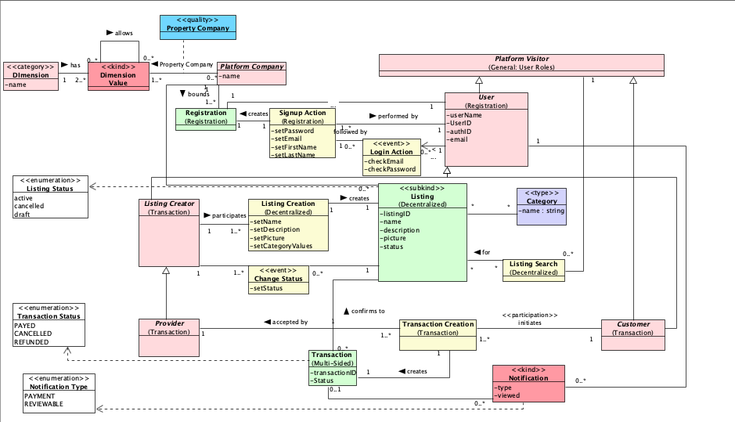

The User type indicates the difference between an individual user, and a professional user. While a professional user is a member of an organisation recognized by the platform company, an individual user is not aligned with an organisation.

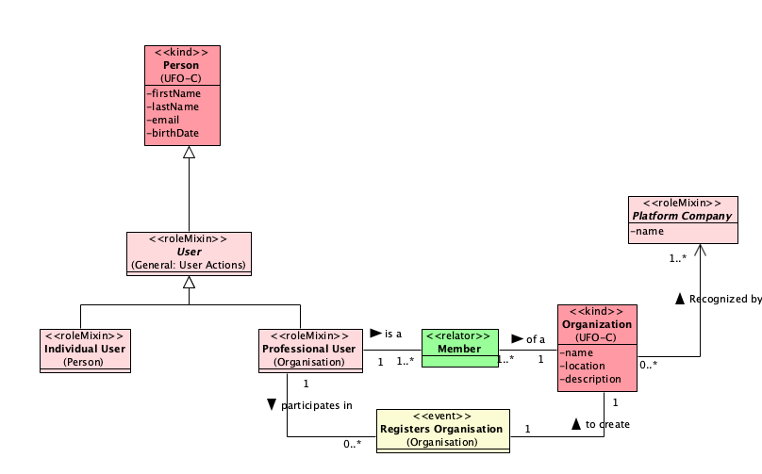
Figure 1: User Type Modules
In Figure 2, the Listing Kind modules capture that a Good Transfer includes a Good, involved in the listing and sold as described by the transaction. A Service on the other hand includes a booking, a certain type of transaction in which a time element is involved.
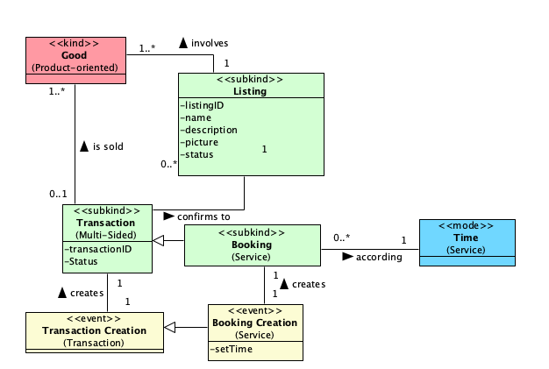
Figure 2: Listing Kind module
In figure 3, a Physical Good requires is a type of good that requires the specification of a delivery location for the delivery of the good. For a Digital Good on the other hand, the digital marketplace requires functionality for a Listing Creator to upload a Digital Good before it can be transferred to another user(s). For a Physical Service, a location at which the service will take place needs to be specified in the Listing, while for an Offline Service a meeting link needs to be captured in the Listing.

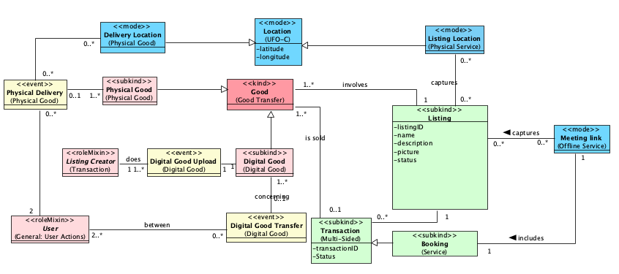
Figure 3: Listing Type modules
In Figure 4, a one-time listing is specified with one time element. While a recurring listing captures numerous available time slots that can be booked.
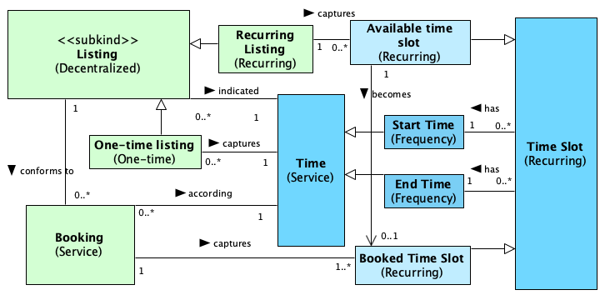
Figure 4: Frequency modules
Figure 5 describes the modules of the Dimension Quantity. In case the quantity is One, the listing is unique and can only be the basis for one transaction. On the other hand, when the quantity is specified as Many, a listing can be the basis of multiple transactions. An available quantity is captured in the listing and a Quantity is captured in the transaction.
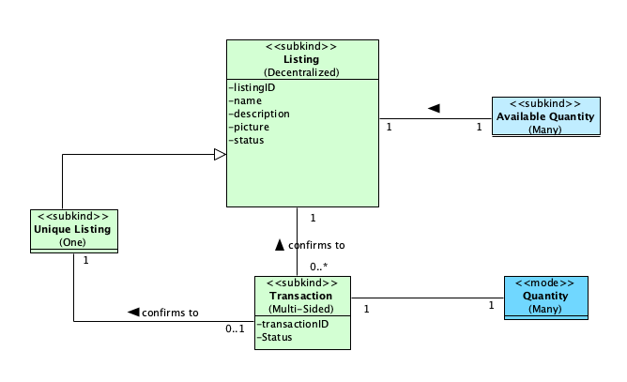
Figure 5: Quantity modules
Figure 6 captures the Price Discovery modules. A price set by provider and captured in the listing. A price suggested by the customer and a price set by the market.

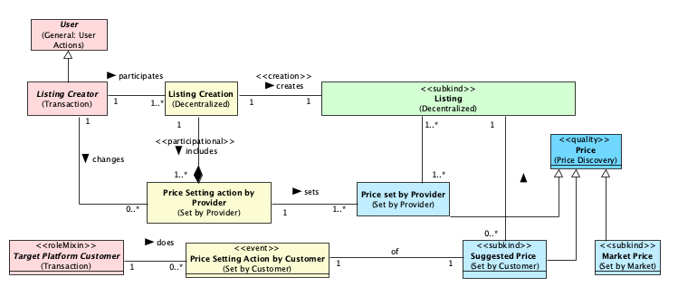
Figure 6: Price Discovery modules
In figure 7, the price calculation module By Quantity entails a price per item, used in the calculation of the transaction price. A Feature-Based Price is connected to its Feature Type and set during the creation of the listing by the provider. The price of the transaction will then depend on the Feature selected. An auction includes Bids from Target Customers, and the highest bid price is used in the transaction price. In case of a Quote, the Target Customer makes a Quote Request. After, a Provider can submit a quote based on the request, and the customer accepts one of the quotes that will be included in the transaction.

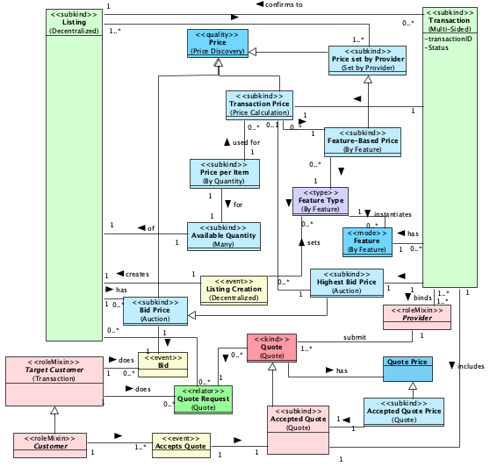
Figure 7: Price Calculation modules

In Figure 8, the Conversation System module illustrates two types of user interactions through message exchanges: Listing Conversation and Transaction Conversation. The Listing Conversation occurs between a potential buyer (the target customer) and the individual who created the listing. This interaction is specifically centered around a particular listing. However, on many platforms, such conversations are either limited, monitored, or prohibited. This restriction is often in place to prevent users from conducting transactions outside the platform, bypassing any platform fees or oversight. On the other hand, a Transaction Conversation is only initiated once a Transaction has been accepted. This type of conversation facilitates further discussion between users regarding the details and specifications of the agreed transaction.

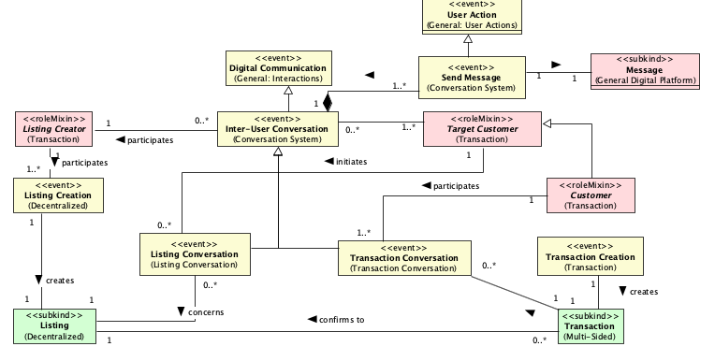
Figure 8: Conversation System modules
The Review By modules in figure 9 capture that depending on the business model choice a Customer and/or a Provider is allowed to create a review concerning a Transaction.

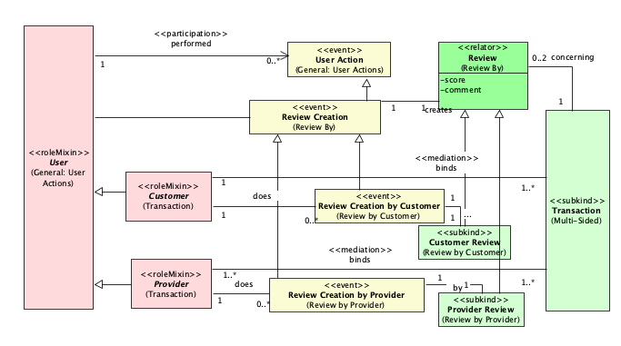
Figure 9: Review By modules
In figure 10, a Review can concern the listing, with the number of reviews and the average review score captured in the listing. Or a Review can concern the provider itself, with the number of reviews and the average score captured on provider level.
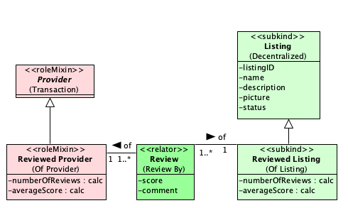
Figure 10: Review Of
There are four different revenue streams captured in figure 11. A Commission Fee is calculated by the Commission Percentage and added to the Transaction Price. A Fixed Fee is also added to the Transaction Price but doesn’t require a calculation. A Subscription Payment Plan is set up during subscription and includes numerous subscription fees t be paid. And a Listing Fee is included during the Listing Creation.
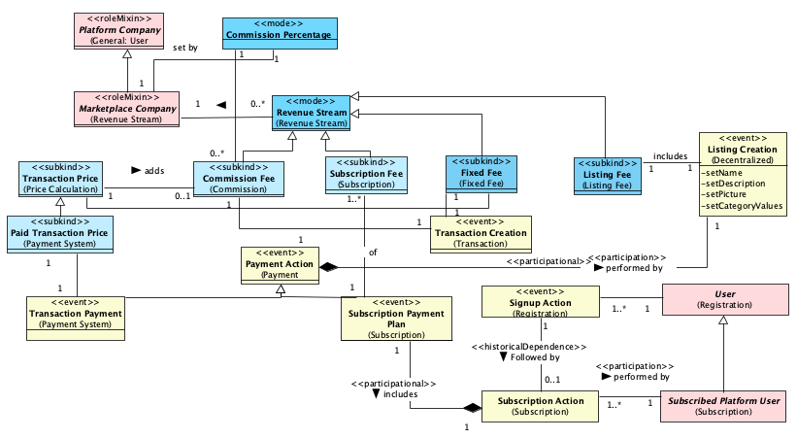
Figure 11: Revenue Stream modules
Figure 12 describes two revenue sources. In case the Customer is the source, the Revenue Steam is paid by the customer. In case the Provider is the source, the Revenue Stream is paid by the Provider.
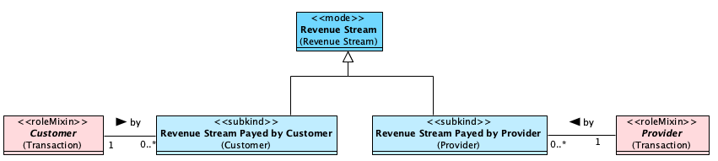
Figure 12: Revenue Source modules

User Stories

As a (role) | I want to (goal) | So that (benefit)

